- Supporting information
Petal-Shaped SnO₂ Free-Standing Electrode with Electrically Conducting Layers via Plasma-Activated Nitrogen Doping Process for High Performance Lithium Ion Batteries

Hyun-Jin Shin^{a,c}, Tae Hyun Kim ^{a,c} , Saleem Abbas ª, Jinhan Cho ^{c}, and Heung Yong Ha*^{,a,b}
ª Center for Energy Storage Research, Korea Institute of Science and Technology (KIST), 14-gil 5, Hwarang-ro, Seongbuk-gu, Seoul 02792, Republic of Korea.
^{b} Department of Energy and Environmental Engineering, Korea University of Science & Technology (UST), 217 Gajeong-ro, Yuseong-gu, Daejeon 34113, Republic of Korea.
^{c} Department of Chemical and Biological Engineering, Korea University, 145 Anam-ro, Seongbuk-gu, Seoul 02841, Republic of Korea.
*Corresponding Author Email: hyha@kist.re.kr

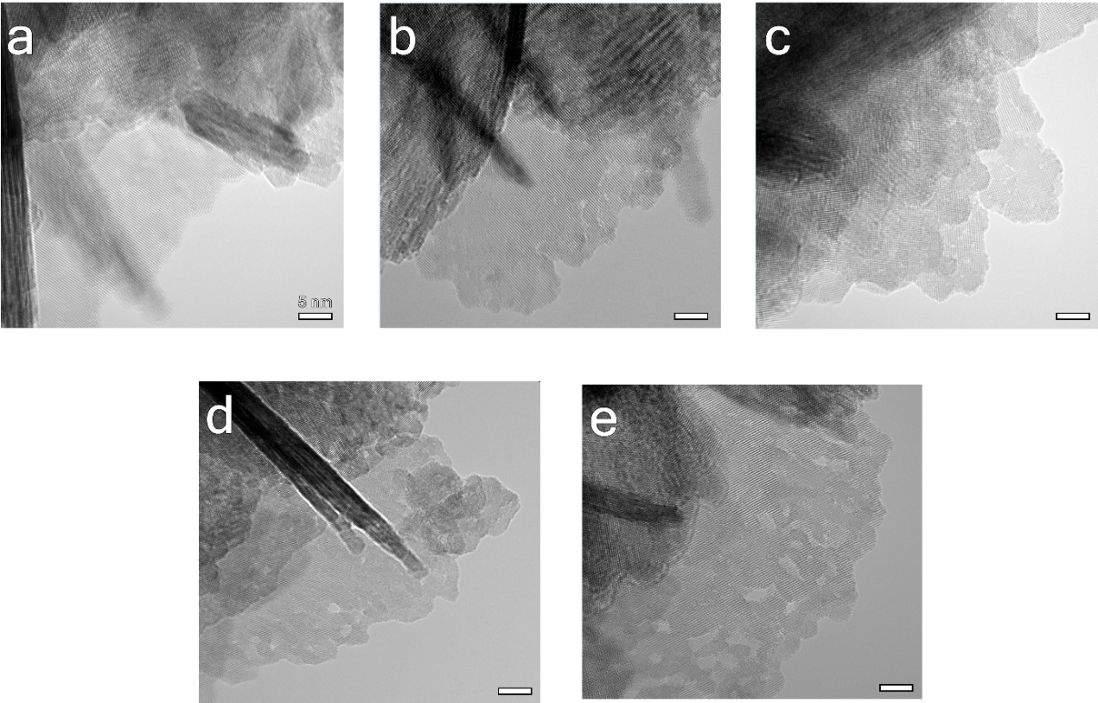
Fig. S1. HR-TEM images of the SnO₂ materials before and after ammonia plasma treatment: (a) pristine, (b) 5N-, (c) 10N-, (d) 15N-, and (e) 20N-SnO₂@CNF.
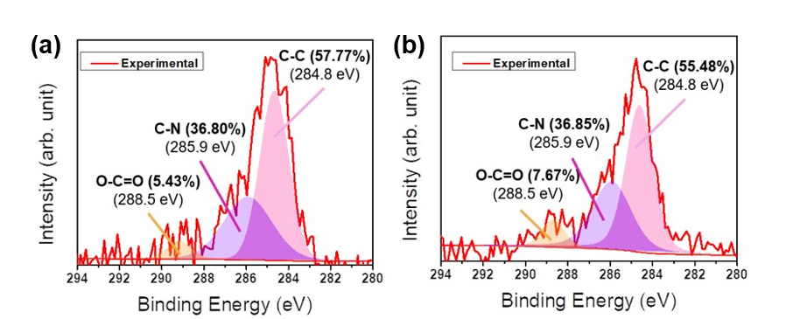
Fig. S2. C1s peaks on XPS spectra for SnO₂@CNF materials: (a) SnO₂@CNF and (b) 20N-SnO₂@CNF.

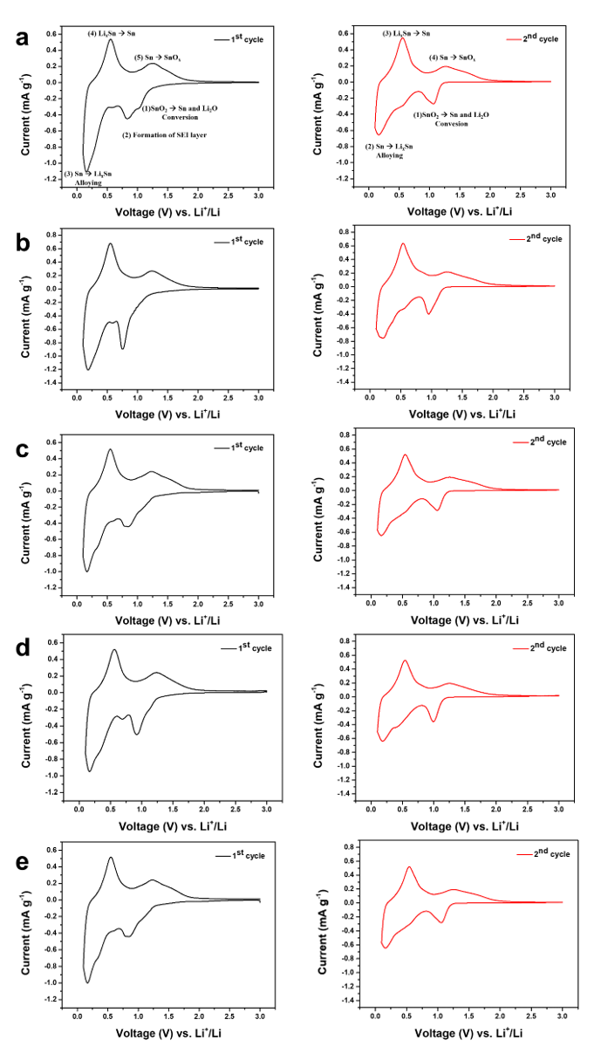
Fig. S3. The first and the second CV profiles for the anode materials at 0.1 mV s⁻¹: (a) pristine, (b) 5N-, (c) 10N-, (d) 15N-, and (e) 20N-SnO₂@CNF.

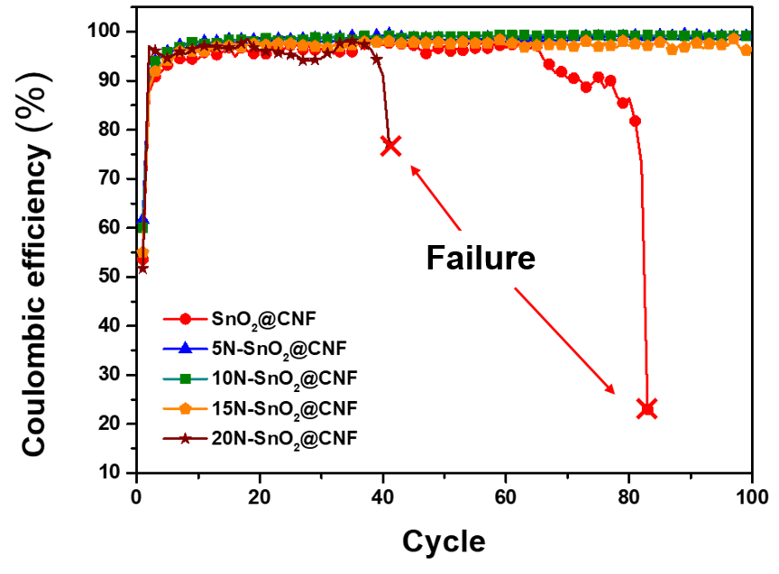
Fig. S4. Changes in Coulombic efficiencies in long-term cycle tests with various anode materials at 0.1 A g⁻¹.

< Table S1. Coulombic efficiencies of the anode materials at 0.1 A g⁻¹ >
Sample | First cycle | 100 cycle
SnO₂@CNF | 53.6% | X
5N-SnO₂@CNF | 61.7% | 99.3%
10N-SnO₂@CNF | 62.0% | 99.3%
15N-SnO₂@CNF | 55.0% | 96.1%
20N-SnO₂@CNF | 51.7% | X

